KENDRIYA VIDYALAYA NO.1

GANDHI NAGAR, JAMMU



**A PROJECT REPORT**

**ON**

“CONTACT MANAGEMENT SYSTEM”

**FOR**

**AISSCE 2016 EXAMINATION**

**As a part of the Informatics Practices Course (065)**

**SUBMITTED BY:**

SABREESH BHATT

ROLL NO- 8

BOARD ROLL NO –

**Under the Guidance of:**

MR. SURJEET SINGH

PGT(CS)

CERTIFICATE

This is to certify that the project/dissertation entitled, CONTACT MANAGEMENT SYSTEM is a bonafide work done by Mr. Sabreesh Bhatt of class 12th A Session 2015-16 in partial fulfilment of CBSE’s AISSCE Examination 2016 and has been carried out under my direct supervision and guidance. This report or a similar report on the topic has not been submitted for any other examination and does not form part of any other course undergone by the candidate.

………………………………….. ……..………………………………

Signature of Student Signature of Teacher/Guide

Name: ……………………………… Name: ………………………………….

Roll no: ……………………………. Designation: …………………………

………………………………………………..

Signature of Principal

Name: ………………………………………………….

Place: ……………………………………

Date: …………………………………….

**ACKNOWLEDGEMENT**

I sincerely thank our IP Teacher Mr. Surjeet Singh for his guidance, encouragement and support throughout the duration of the project. Without his motivation and help the successful completion of this project would not have been possible. I would also like to extend my gratitude to the entire IP department of Kendriya Vidyalaya No. 1, Jammu for their constant support.

Sabreesh Bhatt

12th A

(Name and signature of the student)

Index

1. Certificate
2. Acknowledgement
3. Objective and scope of the project
4. Theoretical Background
5. Definition of Problem
6. System Planning
7. Methodology Adopted, Details of Hardware And Software Used
8. Interface Design and Coding of Methods
9. Structure of Tables
10. Test Report
11. User/Operational Method
12. Brief background of the organization
13. Reference

Objective and scope of the project

#### The goal of this project is to create a contact management system or contact manager which will store all the information of user and enable the user to access that information from it whenever required.

#### **This project has a very wide scope and it can provide the following advantages:**

* Centralized repository of contact information
* Ready to use database with searching
* Sales tracking
* Email integration
* Scheduling of appointments and meetings
* [Document management](https://en.wikipedia.org/wiki/Document_management_system)
* Notes and conversation management
* Customizable fields
* [Drip marketing](https://en.wikipedia.org/wiki/Drip_marketing)
* Import/export utility

Theoretical Background

Contact Manager is an ideal solution for small teams and business professionals who need a simple solution to manage their contacts and help them with day-to-day business activities. An insurance agent or a music composer, a start-up with a team of 5 or a fashion boutique for instance, Contact Manager would be a perfect fit. They might try to use CRM or an address book. But then …..

## **CRM is overkill**

Software is one area, where bigger is not necessarily better. If you find traditional CRM systems to be overwhelming for your needs, then Contact Manager might be a better fit for you.

## **Address Book is too primitive**

You can use an address book mostly to store contacts. Expecting more out of it wouldn't be fair. But Contact Manager can help you with other stuff like tasks, deals, email and team collaboration apart from managing your business contacts.

Definition of Problem

Contact Management System is a must needed software and it was chose to overcome the problems related to storage, access, modification and deletion of contacts smoothly.

Earlier it was very difficult for public to do all these tasks smoothly and comfortably and that is when the concept of the need of CMS arise. Due to the difficulties faced, it was very important to solve all these problems, so that we can save time and do all these tasks without errors.

System Planning

**The planning of this project had proceeded in the following sequence:**

* Basic Idea about Contact Management System
* Outline Imagination for all the frames
* Collection of Data required for Project
* Searching for Required help on the internet and from the subject teacher
* Elements required in each frame
* Tables Required with their attributes
* Coding on all the buttons

Methodology Adopted, Details of Hardware and Software Used

**Methodology Adopted in the making of this project was as follows:**

* Planning of the Structure of the project
* Formation of the frames
* Formation of tables
* Coding in Each Frame and connectivity with database
* Collaboration of all the frames into one major project
* Adding final touch to all the frames

**Hardware Required for the successful run of the project:**

* 1 GHZ Processor
* 1 GB RAM or Above
* Intel Pentium dual core processor or above

**Software Required for the successful run of the project:**

* NetBeans 7.0 or Above
* MySQL 5.1 or Above
* Java Development Kit(jdk)
* Windows Vista or Above

Interface Design and Coding of Methods

1. ***Contact Management System Screen***

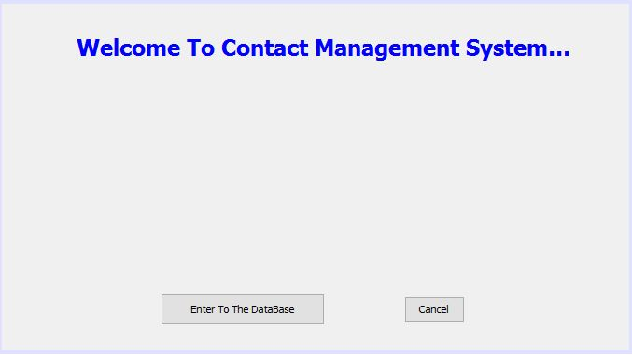

*CODING:*

BUTTON--ENTER TO DATABASE

MainEntryToThePregramme loginform=new MainEntryToThePregramme();

loginform.setVisible(false);

setVisible(false);

*BUTTON--CANCEL*

JOptionPane.showMessageDialog(null,"Thank you for visiting our site!! and to exit please click on the X mark on the upper right corner..");

1. ***Main Entry To The Form***

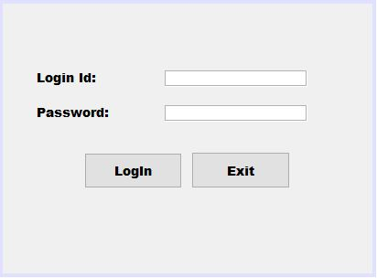

*CODING:*

*BUTTON--LOGIN*

String pwd=new String (pwdFld.getPassword());

if (pwd.equals("pranav"))

{

Msg.setText("Password Valid!");

MainForm loginform=new MainForm();

loginform.setVisible(true);

setVisible(false);

}

else

{

JOptionPane.showMessageDialog(null,"Invalid Password..?");

}

*BUTTON--EXIT*

JOptionPane.showMessageDialog(null," Thanks For Using Database System");

System.exit(0);

1. ***Main Form***

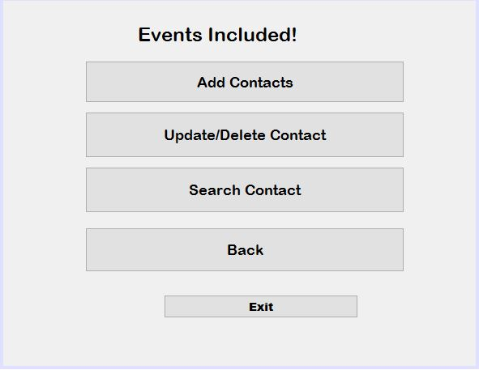

*CODING:*

*Button—update/delete contact*

UpdateDeleteForm loginform=new UpdateDeleteForm();

loginform.setVisible(true);

setVisible(false);

*button—add contacts*

AddContactForm loginform=new AddContactForm();

loginform.setVisible(true);

setVisible(false);

*Button—search contacts*

SearchContactForm loginform=new SearchContactForm();

loginform.setVisible(true);

setVisible(false);

*Button--back*

MainEntryToThePregramme loginform=new MainEntryToThePregramme();

loginform.setVisible(true);

setVisible(false);

*button--exit*

System.exit(0);

1. ***Inner Structure***
2. ***IN “ADD CONTACTS”***

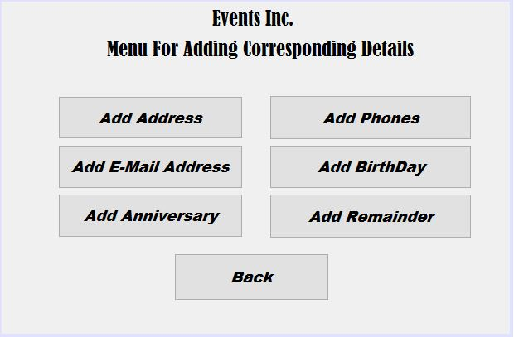

* ***ADD ADDRESS***

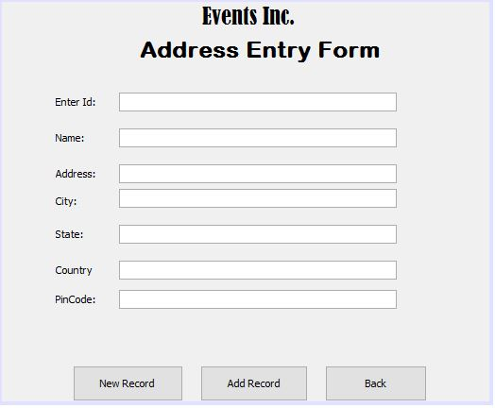

*CODING:*

*BUTTON—NEW RECORD*

Entry_id.setText("");

Person_Name.setText("");

address.setText("");

city.setText("");

state.setText("");

country.setText("");

zipcode.setText("");

BUTTON—ADD RECORD

try

{

Class.forName("com.mysql.jdbc.Driver");

Connection con= (Connection)

DriverManager.getConnection("jdbc:mysql:// localhost:3306/cms","root","");

Statement stmt=con.createStatement();

String id =Entry_id.getText();

String name= Person_Name.getText();

String addr =address.getText();

String cty =city.getText();

String st =state.getText();

String cntry =country.getText();

String zp =zipcode.getText();

String str="insert into address(id,name,address,city,state,country,pincode) values('"+(id)+"',+'"+(name )+"',+'"+(addr)+"',+'"+(cty)+"',+'"+(st)+"',+'"+(cntry)+"',+'"+(zp)+"')";

int r= stmt.executeUpdate(str);

JOptionPane.showMessageDialog(this,"Record inserted"+r);

}

catch(Exception e)

{

JOptionPane.showMessageDialog(this,e.getMessage());

e.printStackTrace();

}

BUTTON--BACK

AddContactForm loginform=new AddContactForm();

loginform.setVisible(true);

setVisible(false);

* ***ADD EMAIL ADDRESS***

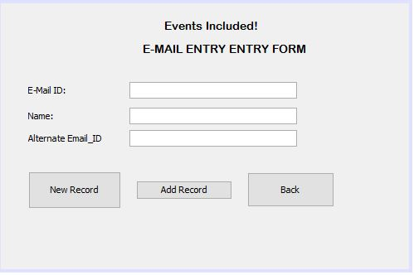

*CODING:*

BUTTON—ADD RECORD

try

{

Class.forName("com.mysql.jdbc.Driver");

Connection con= (Connection)

DriverManager.getConnection("jdbc:mysql://localhost:3306/cms","root","");

Statement stmt=con.createStatement();

String emid =jTextField2.getText();

String n= jTextField3.getText();

String alteremail =jTextField1.getText();

String str="insert into email(email,name,alteid) values('"+(emid)+"',+'"+(n)+"','"+(alteremail)+"')";

int r= stmt.executeUpdate(str);

JOptionPane.showMessageDialog(this,"Record inserted"+r);

}

catch(Exception e)

{

JOptionPane.showMessageDialog(this,e.getMessage());

e.printStackTrace();

}

BUTTON--BACK

AddContactForm loginform=new AddContactForm();

loginform.setVisible(true);

setVisible(false);

* ***ADD ANNIVERSARY***

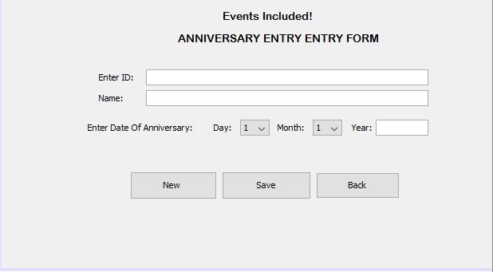

*CODING:*

Button—save

try

{

Class.forName("com.mysql.jdbc.Driver");

Connection con= (Connection)

DriverManager.getConnection("jdbc:mysql://localhost:3306/cms","root","");

Statement stmt=con.createStatement();

int id =Integer.parseInt(jTextField1.getText());

String n= jTextField2.getText();

int d =Integer.parseInt(jComboBox1.getSelectedItem().toString());

int m =Integer.parseInt(jComboBox2.getSelectedItem().toString());

int yr=Integer.parseInt( jTextField3.getText());

String str="insert into aniversry(id,name,day,month,year) values('"+(id)+"',+'"+(n)+"','"+(d)+"','"+(m)+"','"+(yr)+"')";

int r= stmt.executeUpdate(str);

JOptionPane.showMessageDialog(this,"Record inserted"+r);

}

catch(Exception e)

{

JOptionPane.showMessageDialog(this,e.getMessage());

e.printStackTrace();

}

Button--back

AddContactForm loginform=new AddContactForm();

loginform.setVisible(true);

setVisible(false);

* ***ADD PHONES***

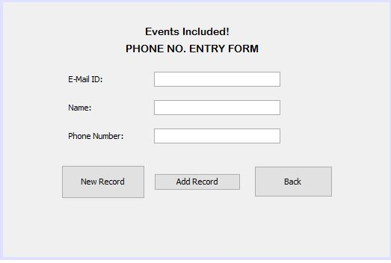

*CODING:*

Button—add record

try

{

Class.forName("com.mysql.jdbc.Driver");

Connection con= (Connection) DriverManager.getConnection("jdbc:mysql://localhost:3306/cms","root","");

Statement stmt=con.createStatement();

String em =jTextField1.getText();

String name= jTextField2.getText();

int ph =Integer.parseInt(jTextField3.getText());

String str="insert into phone(email,name,phno) values('"+(em)+"',+'"+(name )+"','"+(ph)+"')";

int r= stmt.executeUpdate(str);

JOptionPane.showMessageDialog(this,"Record inserted"+r);

}

catch(Exception e)

{

JOptionPane.showMessageDialog(this,e.getMessage());

e.printStackTrace();

}

Button--back

AddContactForm loginform=new AddContactForm();

loginform.setVisible(true);

setVisible(false);

* ***ADD BIRTHDAY***

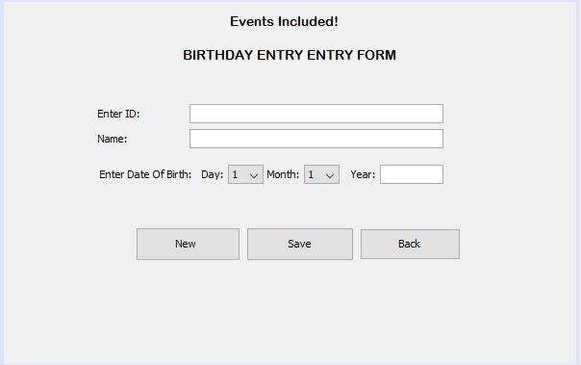

*CODING:*

Button—save

try

{

Class.forName("com.mysql.jdbc.Driver");

Connection con= (Connection)

DriverManager.getConnection("jdbc:mysql://localhost:3306/cms","root","");

Statement stmt=con.createStatement();

int id =Integer.parseInt(jTextField1.getText());

String n= jTextField2.getText();

int d =Integer.parseInt(jComboBox1.getSelectedItem().toString());

int m =Integer.parseInt(jComboBox2.getSelectedItem().toString());

int yr=Integer.parseInt( jTextField3.getText());

String str="insert into birthday(id,name,day,month,year) values('"+(id)+"',+'"+(n)+"','"+(d)+"','"+(m)+"','"+(yr)+"')";

int r= stmt.executeUpdate(str);

JOptionPane.showMessageDialog(this,"Record inserted"+r);

}

catch(Exception e)

{

JOptionPane.showMessageDialog(this,e.getMessage());

e.printStackTrace();

}

Button--back

AddContactForm loginform=new AddContactForm();

loginform.setVisible(true);

setVisible(false);

* ***ADD REMAINDER***

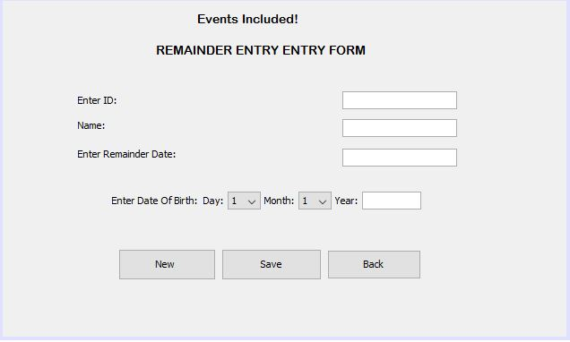

*CODING:*

Button—save

try

{

Class.forName("com.mysql.jdbc.Driver");

Connection con= (Connection)

DriverManager.getConnection("jdbc:mysql://localhost:3306/cms","root","");

Statement stmt=con.createStatement();

int id =Integer.parseInt(jTextField1.getText());

String n= jTextField2.getText();

String rd=jTextField4.getText();

int d =Integer.parseInt(jComboBox3.getSelectedItem().toString());

int m =Integer.parseInt(jComboBox4.getSelectedItem().toString());

int yr=Integer.parseInt( jTextField3.getText());

String str="insert into remainder(id,name,rem_date,day,month,year) values('"+(id)+"',+'"+(n)+"','"+(rd)+"','"+(d)+"','"+(m)+"','"+(yr)+"')";

int r= stmt.executeUpdate(str);

JOptionPane.showMessageDialog(this,"Record inserted"+r);

}

catch(Exception e)

{

JOptionPane.showMessageDialog(this,e.getMessage());

e.printStackTrace();

}

Button--back

AddContactForm loginform=new AddContactForm();

loginform.setVisible(true);

setVisible(false);

1. ***IN “UPDATE/DELETE CONTACTS”***

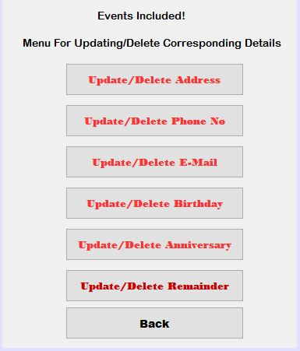

* ***UPDATE/DELETE PHONE NO.***

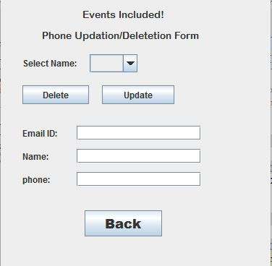

*CODING:*

BUTTON—DELETE

try

{

Class.forName("com.mysql.jdbc.Driver");

Connection con1= (Connection)

DriverManager.getConnection("jdbc:mysql://localhost:3306/cms","root","");

Statement stmt1=con1.createStatement();

String n=(String)jComboBox1.getSelectedItem();

String str1="delete from phone where name='"+(n)+"'";

ResultSet rs1;

int r = stmt1.executeUpdate(str1);

System.out.println(r);

jComboBox1.removeItem(n);

}

catch(Exception e)

{

JOptionPane.showMessageDialog(this,e.getMessage());

e.printStackTrace();

}

BUTTON—UPDATE

try

{

Class.forName("com.mysql.jdbc.Driver");

Connection con1= (Connection)

DriverManager.getConnection("jdbc:mysql://localhost:3306/cms","root","");

Statement stmt1=con1.createStatement();

String n=(String)jComboBox1.getSelectedItem();

String em=jTextField1.getText();

String name=jTextField2.getText();

String ph=jTextField3.getText();

String str2="update phone set name='"+(name)+"', email='"+(em)+"',phno='"+(ph)+"' where name='"+(n)+"'";

ResultSet rs2;

int r = stmt1.executeUpdate(str2);

JOptionPane.showMessageDialog(this,"Record Updated");

}

catch(Exception e)

{

JOptionPane.showMessageDialog(this,e.getMes sage());

e.printStackTrace();

}

BUTTON--BACK

UpdateDeleteForm loginform=new UpdateDeleteForm();

loginform.setVisible(true);

setVisible(false);

* ***UPDATE/DELETE EMAIL***

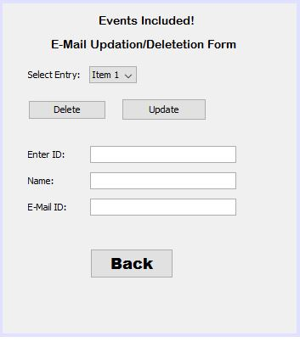

*CODING:*

BUTTON—DELETE

try

{

Class.forName("com.mysql.jdbc.Driver");

Connection con1= (Connection)

DriverManager.getConnection("jdbc:mysql://localhost:3306/cms","root","");

Statement stmt1=con1.createStatement();

String n=(String)jComboBox1.getSelectedItem();

String str1="delete from email where name='"+(n)+"'";

ResultSet rs1;

int r = stmt1.executeUpdate(str1);

System.out.println(r);

jComboBox1.removeItem(n);

}

catch(Exception e)

{

JOptionPane.showMessageDialog(this,e.getMessage());

e.printStackTrace();

}

BUTTON—UPDATE

try

{

Class.forName("com.mysql.jdbc.Driver");

Connection con1= (Connection)

DriverManager.getConnection("jdbc:mysql://localhost:3306/cms","root","");

Statement stmt1=con1.createStatement();

String n=(String)jComboBox1.getSelectedItem();

String em=jTextField1.getText();

String name=jTextField2.getText();

String str2="update email set name='"+(name)+"', email='"+(em)+"' where name='"+(n)+"'";

ResultSet rs2;

int r = stmt1.executeUpdate(str2);

JOptionPane.showMessageDialog(this,"Record Updated");

}

catch(Exception e)

{

JOptionPane.showMessageDialog(this,e.getMes sage());

e.printStackTrace();

}

BUTTON--BACK

UpdateDeleteForm loginform=new UpdateDeleteForm();

loginform.setVisible(true);

setVisible(false);

* ***UPDATE/DELETE BIRTHDAY***

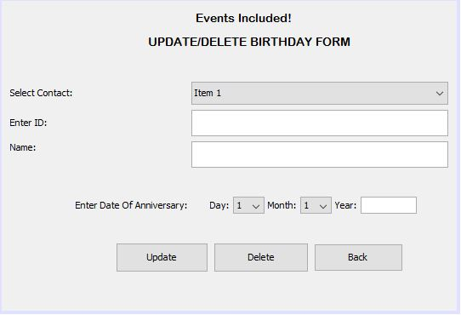

*CODING:*

BUTTON—DELETE

try

{

Class.forName("com.mysql.jdbc.Driver");

Connection con1= (Connection)

DriverManager.getConnection("jdbc:mysql:// localhost:3306/cms","root","");

Statement stmt1=con1.createStatement();

String n=(String)jComboBox1.getSelectedItem();

String str1="delete from birthday where name='"+(n)+"'";

ResultSet rs1;

int r = stmt1.executeUpdate(str1);

System.out.println(r);

jComboBox1.removeItem(n);

}

catch(Exception e)

{

JOptionPane.showMessageDialog(this,e.getMessage());

e.printStackTrace();

}

BUTTON—UPDATE

try

{

Class.forName("com.mysql.jdbc.Driver");

Connection con1= (Connection)

DriverManager.getConnection("jdbc:mysql://localhost:3306/cms","root","");

Statement stmt1=con1.createStatement();

String n=(String)jComboBox1.getSelectedItem();

String em=jTextField1.getText();

String name=jTextField2.getText();

int d =Integer.parseInt(jComboBox1.getSelectedItem().toString());

int m =Integer.parseInt(jComboBox2.getSelectedItem().toString());

int y=Integer.parseInt( jTextField3.getText());

String str2="update birthday set name='"+(name)+"',d='"+(d)+"' ,m='"+(m)+"',y='"+(y)+"'where name='"+(n)+"'";

ResultSet rs2;

int r = stmt1.executeUpdate(str2);

JOptionPane.showMessageDialog(this,"Record Updated");

}

catch(Exception e)

{

JOptionPane.showMessageDialog(this,e.getMes sage());

e.printStackTrace(); }

BUTTON—back

UpdateDeleteForm loginform=new UpdateDeleteForm();

loginform.setVisible(true);

setVisible(false);

* ***UPDATE/DELETE ANNIVERSARY***

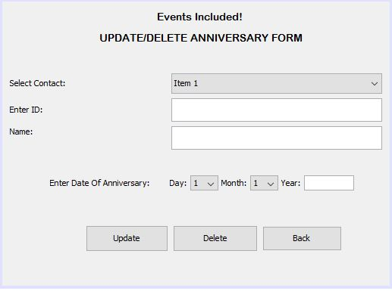

*CODING:*

BUTTON—DELETE

try

{

Class.forName("com.mysql.jdbc.Driver");

Connection con1= (Connection)

DriverManager.getConnection("jdbc:mysql:// localhost:3306/cms","root","");

Statement stmt1=con1.createStatement();

String n=(String)jComboBox1.getSelectedItem();

String str1="delete from aniversry where name='"+(n)+"'";

ResultSet rs1;

int r = stmt1.executeUpdate(str1);

System.out.println(r);

jComboBox1.removeItem(n);

}

catch(Exception e)

{

JOptionPane.showMessageDialog(this,e.getMessage());

e.printStackTrace();

}

BUTTON—UPDATE

try

{

Class.forName("com.mysql.jdbc.Driver");

Connection con1= (Connection)

DriverManager.getConnection("jdbc:mysql://localhost:3306/cms","root","");

Statement stmt1=con1.createStatement();

String n=(String)jComboBox1.getSelectedItem();

String em=jTextField1.getText();

String name=jTextField2.getText();

int d =Integer.parseInt(jComboBox1.getSelectedItem().toString());

int m =Integer.parseInt(jComboBox2.getSelectedItem().toString());

int y=Integer.parseInt( jTextField3.getText());

String str2="update aniversry set name='"+(name)+"',d='"+(d)+"' ,m='"+(m)+"',y='"+(y)+"'where name='"+(n)+"'";

ResultSet rs2;

int r = stmt1.executeUpdate(str2);

JOptionPane.showMessageDialog(this,"Record Updated");

}

catch(Exception e)

{

JOptionPane.showMessageDialog(this,e.getMes sage());

e.printStackTrace(); }

BUTTON—back

UpdateDeleteForm loginform=new UpdateDeleteForm();

loginform.setVisible(true);

setVisible(false);

* *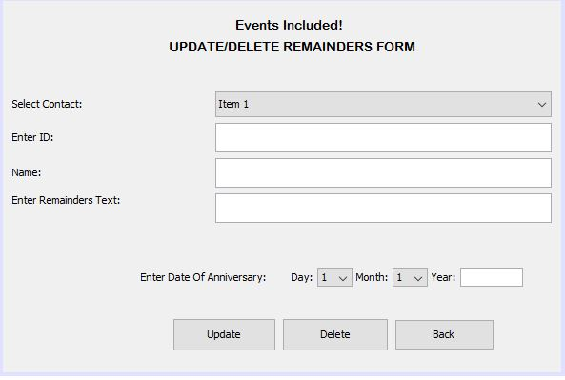****UPDATE/DELETE REMAINDER***

*CODING:*

BUTTON—DELETE

try

{

Class.forName("com.mysql.jdbc.Driver");

Connection con1= (Connection)

DriverManager.getConnection("jdbc:mysql:// localhost:3306/cms","root","");

Statement stmt1=con1.createStatement();

String n=(String)jComboBox1.getSelectedItem();

String str1="delete from aniversry where name='"+(n)+"'";

ResultSet rs1;

int r = stmt1.executeUpdate(str1);

System.out.println(r);

jComboBox1.removeItem(n);

}

catch(Exception e)

{

JOptionPane.showMessageDialog(this,e.getMessage());

e.printStackTrace();

}

BUTTON—UPDATE

try

{

Class.forName("com.mysql.jdbc.Driver");

Connection con1= (Connection)

DriverManager.getConnection("jdbc:mysql://localhost:3306/cms","root","");

Statement stmt1=con1.createStatement();

String n=(String)jComboBox1.getSelectedItem();

String em=jTextField1.getText();

String name=jTextField2.getText();

String rem=jTextField3.getText();

int d =Integer.parseInt(jComboBox1.getSelectedItem().toString());

int m =Integer.parseInt(jComboBox2.getSelectedItem().toString());

int y=Integer.parseInt( jTextField4.getText());

String str2="update remainder set name='"+(name)+"',rem='"+(rem)+"',d='"+(d)+"' ,m='"+(m)+"',y='"+(y)+"'where name='"+(n)+"'";

ResultSet rs2;

int r = stmt1.executeUpdate(str2);

JOptionPane.showMessageDialog(this,"Record Updated");

}

catch(Exception e)

{

JOptionPane.showMessageDialog(this,e.getMes sage());

e.printStackTrace(); }

BUTTON—back

UpdateDeleteForm loginform=new UpdateDeleteForm();

loginform.setVisible(true);

setVisible(false);

1. ***IN “SEARCH CONTACTS”***

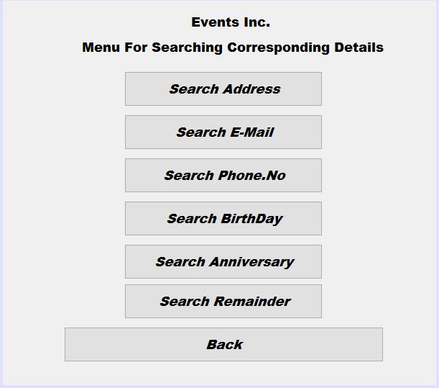

* ***SEARCH ADDRESS***

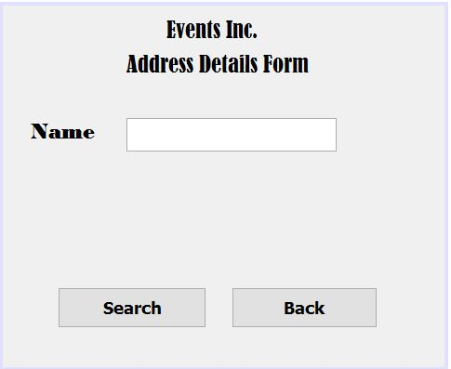

*CODING:*

BUTTON—SEARCH

try

{Class.forName("com.mysql.jdbc.Driver");

Connection con= (Connection) DriverManager.getConnection("jdbc:mysql://localhost:3306/cms","root","");

Statement stmt=con.createStatement();

String id =jTextField1.getText();

String str="Select * from address where name='"+id+"'";

ResultSet s=stmt.executeQuery(str);

while (s.next())

{String id1=s.getString("id");

String uname=s.getString("name");

String uaddress=s.getString("address");

String ucity=s.getString("city");

String ustate=s.getString("state");

String ucountry=s.getString("country");

String upincode=s.getString("pincode");

jLabel4.setText("ID : "+id1+" Name is : "+uname+" City is : "+ucity+" State is :"+ ustate+" Country is : "+ucountry+" Pincode is : "+upincode+"\n"); }

}

catch(Exception e)

{JOptionPane.showMessageDialog(this,e.getMessage());

e.printStackTrace();}

BUTTON—BACK

SearchContactForm loginform=new SearchContactForm();

loginform.setVisible(true);

setVisible(false);

* *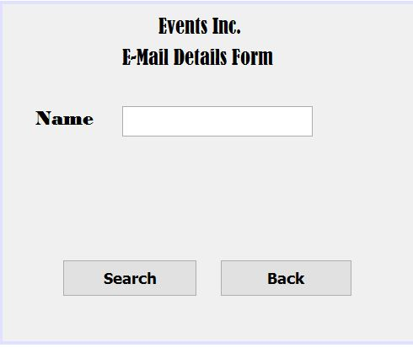****SEARCH E-MAIL***

*CODING:*

BUTTON—SEARCH

try

{

Class.forName("com.mysql.jdbc.Driver");

Connection con= (Connection) DriverManager.getConnection("jdbc:mysql://localhost:3306/cms","root","");

Statement stmt=con.createStatement();

String id =jTextField1.getText();

String str="Select * from email where name='"+id+"'";

ResultSet s=stmt.executeQuery(str);

while (s.next())

{String id1=s.getString("email");

String uname=s.getString("name");

String uaddress=s.getString("alteid");

jLabel4.setText("Email : "+id1+" Name is : "+uname+" Alternet EmailID is : "+uaddress+"\n"); }

}

catch(Exception e)

{

JOptionPane.showMessageDialog(this,e.getMessage());

e.printStackTrace();

}

BUTTON—BACK

SearchContactForm loginform=new SearchContactForm();

loginform.setVisible(true);

setVisible(false);

* *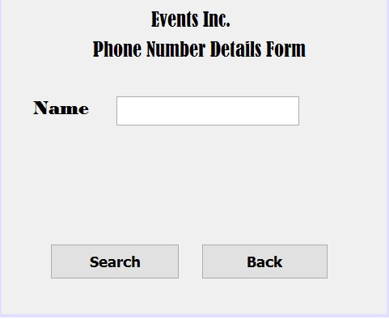****SEARCH PHONE NO.***

*CODING:*

BUTTON—SEARCH

try

{

Class.forName("com.mysql.jdbc.Driver");

Connection con= (Connection)

DriverManager.getConnection("jdbc:mysql://localhost:3306/cms","root","");

Statement stmt=con.createStatement();

String id =jTextField1.getText();

String str="Select * from phone where name='"+id+"'";

ResultSet s=stmt.executeQuery(str);

while (s.next())

{

String id1=s.getString("email");

String uname=s.getString("name");

String uaddress=s.getString("phno");

jLabel4.setText(" Your Email : "+id1+" Name is : "+uname+" And Phone is : "+uaddress+"\n"); }

}

catch(Exception e)

{

JOptionPane.showMessageDialog(this,e.getMessage());

e.printStackTrace();}

BUTTON—BACK

SearchContactForm loginform=new SearchContactForm();

loginform.setVisible(true);

setVisible(false);

* *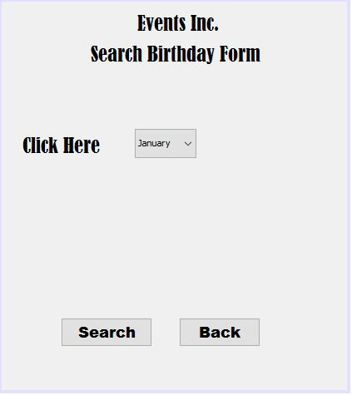****SEARCH BIRTHDAY***

*CODING:*

BUTTON—SEARCH

try

{

Class.forName("com.mysql.jdbc.Driver");

Connection con= (Connection)

DriverManager.getConnection("jdbc:mysql://localhost:3306/cms","root","");

Statement stmt=con.createStatement();

int id =jComboBox1.getSelectedIndex();

id+=1;

String str="Select * from birthday where month="+id+"";

ResultSet s=stmt.executeQuery(str);

while (s.next())

{

String id1=s.getString("id");

String uname=s.getString("name");

String uaddress=s.getString("day");

String ucity=s.getString("month");

String ustate=s.getString("year");

jLabel4.setText("ID : "+id1+" Name is : "+uname+" Day is : "+uaddress+" Month is :"+ ucity+" Year is : "+ustate+"\n"); }

}

catch(Exception e)

{

JOptionPane.showMessageDialog(this,e.getMessage());

e.printStackTrace();}

BUTTON—BACK

SearchContactForm loginform=new SearchContactForm();

loginform.setVisible(true);

setVisible(false);

* ***SEARCH ANNIVERSARY***

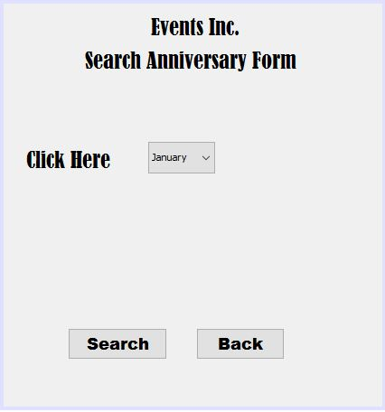

*CODING:*

BUTTON—SEARCH

try

{

Class.forName("com.mysql.jdbc.Driver");

Connection con= (Connection) DriverManager.getConnection("jdbc:mysql://localhost:3306/cms","root","");

Statement stmt=con.createStatement();

int id =jComboBox1.getSelectedIndex();

id+=1;

String str="Select * from aniversry where month="+id+"";

ResultSet s=stmt.executeQuery(str);

while (s.next())

{

String id1=s.getString("id");

String uname=s.getString("name");

String uaddress=s.getString("day");

String ucity=s.getString("month");

String ustate=s.getString("year");

jLabel4.setText("ID : "+id1+" Name is : "+uname+" Day is : "+uaddress+" Month is :"+ ucity+" Year is : "+ustate+"\n");}

}

catch(Exception e)

{JOptionPane.showMessageDialog(this,e.getMessage());

e.printStackTrace();}

BUTTON—BACK

SearchContactForm loginform=new SearchContactForm();

loginform.setVisible(true);

setVisible(false);

* ***SEARCH REMAINDER***

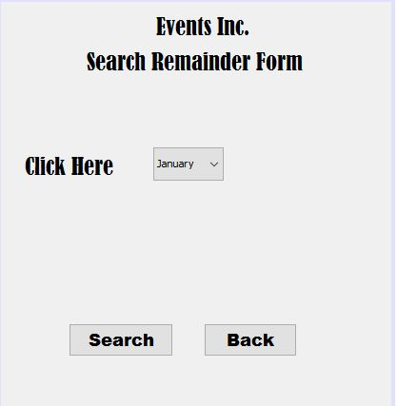

*CODING:*

BUTTON—SEARCH

try

{

Class.forName("com.mysql.jdbc.Driver");

Connection con= (Connection) DriverManager.getConnection("jdbc:mysql://localhost:3306/cms","root","");

Statement stmt=con.createStatement();

int id =jComboBox1.getSelectedIndex();

id+=1;

String str="Select * from remainder where month="+id+"";

ResultSet s=stmt.executeQuery(str);

while (s.next())

{

String id1=s.getString("id");

String uname=s.getString("name");

String uaddress=s.getString("rem_date");

String uday=s.getString("day");

String umonth=s.getString("month");

String uyear=s.getString("year");

jLabel4.setText(" ID is : "+id1+" Name is : "+uname+" Rem Date is : "+uaddress+" Day is : "+uday+" Month is"+umonth+" year is : "+uyear+"\n");}

}

catch(Exception e)

{JOptionPane.showMessageDialog(this,e.getMessage());

e.printStackTrace();}

BUTTON—BACK

SearchContactForm loginform=new SearchContactForm();

loginform.setVisible(true);

setVisible(false);

1. ***BACK***

MainEntryToThePregramme loginform=new MainEntryToThePregramme();

loginform.setVisible(true);

setVisible(false);

1. ***EXIT***

System.exit(0);

STRUCTURE OF TABLES

The Tables Used in the making of this project are as follows:

1. 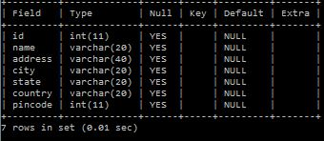ADDRESS TABLE
2. EMAIL TABLE

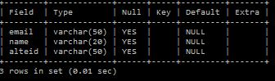

1. ANIVERSRY TABLE

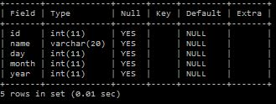

1. PHONE TABLE

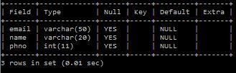

1. BIRTHDAY TABLE

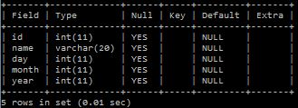

1. REMAINDER TABLE

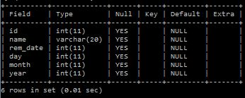

Test report

This report certifies that I have checked and run the project myself and it worked perfectly without any kind of problem.

The following are some results generated during the successful completion and run of the project:

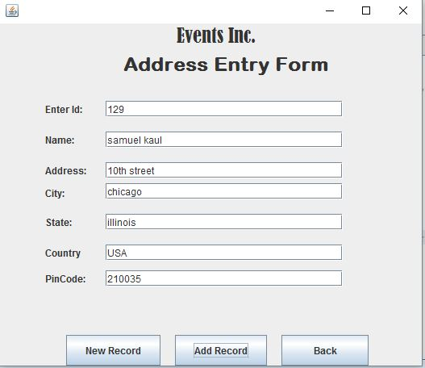

When the add record button was clicked it stored the information in the database without any error and the same can be seen in the screenshot of the table given below:

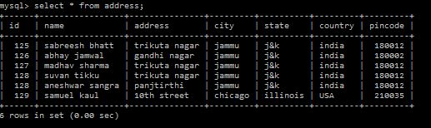

User/operational manual

The following set of images are some instructions which will help in the successful and lag-free run of the project.Follow the guidelines given to run the project easily.

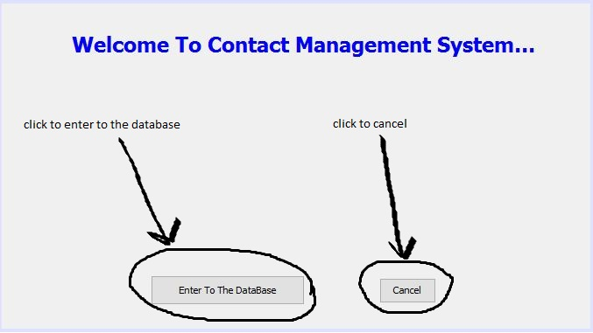

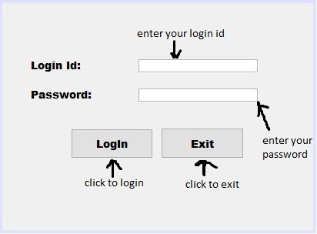

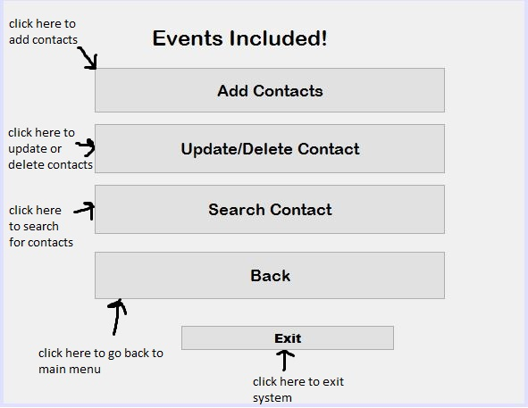

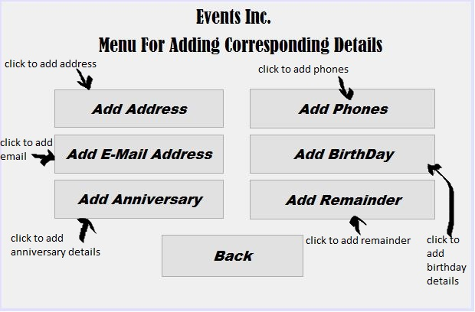

OR

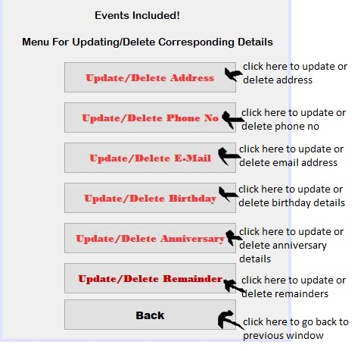

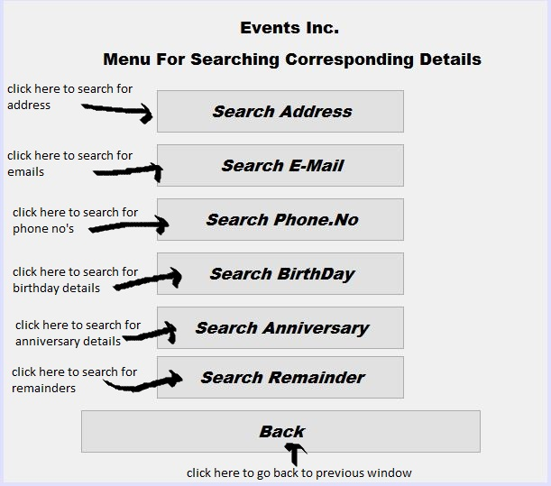OR

Brief background of the organisation

Broadways Inc., a multinational company headquarted in new delhi,india had the problem of storing the particulars of their employees. So they required a program which could solve their problem efficiently and could be user friendly so that each employee of their company can use and get benefited from it easily.So I came up with the idea of designing a contact management system which could the the required seamlessly and without causing any kind of trouble to its users. This program can solve their problem and can help them to maximum.In this manner they can manage the particulars very easily and can use them anytime and anywhere.

reference

* *INFORMATICS PRACTICES TEXTBOOK FOR CLASS 12 BY NCERT PUBLICATIONS*
* *INFORMATICS PRACTICES BY SUMITA ARORA BY DHANPAT RAI PUBLICATIONS*
* *ARIHANT’S ALL IN ONE FOR INFORMATICS PRACTICES*
* [*www.meritnation.com*](http://www.meritnation.com)
* [*www.studiestoday.com*](http://www.studiestoday.com)